North Park Sports Complex (Bubble)

Address: 2330 Wildwood Road, Allison Park, PA 15101

GPS Coordinates: 40.593438, -79.978189
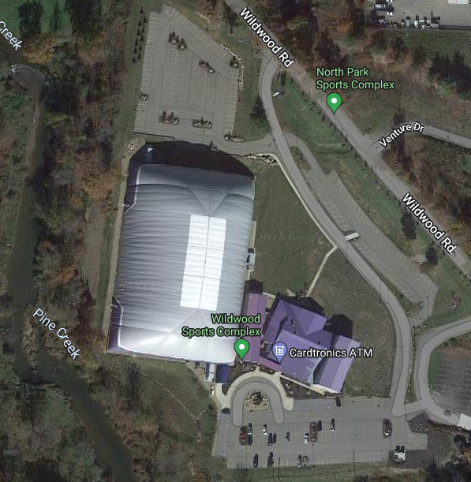
- EMS Arrival Location on Wildwood Road
- (Bubble entrance)
Receiving Facility:
UPMC Passavant Hospital
9100 Babcock Blvd.
Pittsburgh, PA 15237
412-367-6700

Roles of Emergency Personnel
- First Responder provides immediate care of the injured athlete.
  - Evaluate level of consciousness
  - Evaluate Cardiorespiratory status via checking CAB’s.
  - Maintain C-Spine neutral alignment if a head/neck injury is suspected.
  - Control any excessive bleeding by direct pressure.
  - Determine what emergency equipment is required for situation.
- Activation of EAP and additional medical personnel. 911
- Emergency equipment retrieval
- Direct an individual to meet, or “flag down” arriving EMS at EMS Arrival location.

Venue Directions
The North Park Sports Complex is located on Wildwood Road in Allison Park. EMS can access the Wildwood Sports Complex at the EMS Arrival Location on Wildwood Road. Someone will meet the EMS at the Bubble Entrance and direct them into the Bubble.

Emergency Personnel
In the event of a medical emergency, first responders (FR) may include physicians, athletic trainers, athletic training students, coaches, athletic department staff, campus security, and/or EMS depending on the situation. The FR should be the most medically trained person and the individual directing care during the emergency situation. In most cases, the FR will be the athletic trainer.

Emergency Communication
Certified Athletic Trainers Carry Cell phones

Brian Beck (804) 614-5485
William Couts (412) 417-0619

Main Athletic Training Room landline phone
(412) 536-1006

LaRoche University Security
(412) 536-1111

Emergency Equipment
An AED is located on the wall across from the information desk.

