LaRoche University Softball Complex

Address: 9000 Babcock Blvd. Pittsburgh, PA 15237

GPS Coordinates: 40.568115, -80.009984

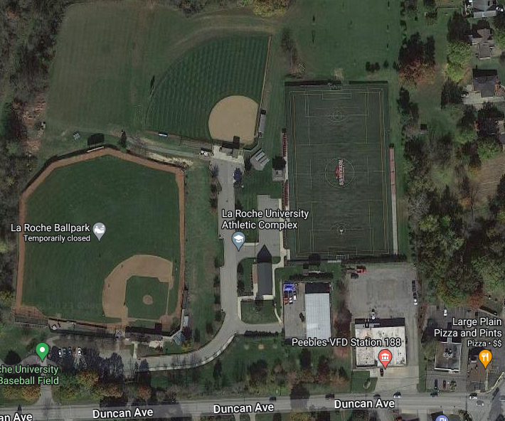
- EMS Arrival Location
Receiving Facility:
UPMC Passavant Hospital
9100 Babcock Blvd.
Pittsburgh, PA 15237
412-367-6700

Roles of Emergency Personnel
- First Responder provides immediate care of the injured athlete.
  - Evaluate level of consciousness
  - Evaluate Cardiorespiratory status via checking CAB’s.
  - Maintain C-Spine neutral alignment if a head/neck injury is suspected.
  - Control any excessive bleeding by direct pressure.
  - Determine what emergency equipment is required for situation.
- Activation of EAP and additional medical personnel. 911
- Emergency equipment retrieval
- Direct an individual to meet, or “flag down” arriving EMS at EMS Arrival location.

Venue Directions
The LaRoche University Softball Complex is located on Duncan Avenue between Peebles Road and Remington Drive. EMS can access the LaRoche Softball Complex at the EMS Arrival Location. Someone will meet the EMS at the EMS Arrival Location and direct them to the softball field.

Emergency Personnel
In the event of a medical emergency, first responders (FR) may include physicians, athletic trainers, athletic training students, coaches, athletic department staff, campus security, and/or EMS depending on the situation. The FR should be the most medically trained person and the individual directing care during the emergency situation. In most cases, the FR will be the athletic trainer.

Emergency Communication
Certified Athletic Trainers Carry Cell phones

Brian Beck (804) 614-5485
William Couts (412) 4170619
Main Athletic Training Room landline phone
(412) 536-1006
LaRoche University Security
(412) 536-1111

Emergency Equipment
Emergency supplies including but not limited to: first aid supplies, splints, and crutches and AED are located in the Athletic Training Room on the 1st floor of the Kerr Fitness Center outside the men’s basketball locker room. Additional equipment can be accessed from the Kerr Fitness Center athletic training room. Additional AEDs are located on a pillar in front of the information desk on the 2nd level of the Kerr Fitness Center as well as the Soccer Complex Press Box.

